Additional file 2. Frequency distribution of answers to each item before (t0, top graph) and after (t1, bottom graph) the e-TUDE training program in the study group

Figure B.1 Item 1
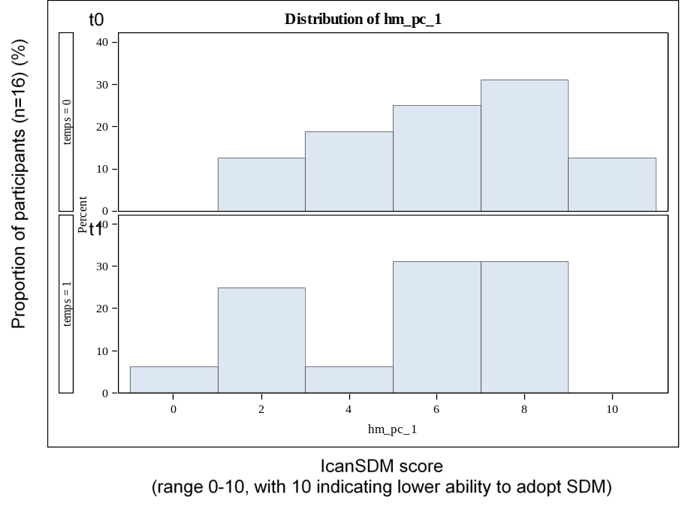

Figure B.2 Item 2
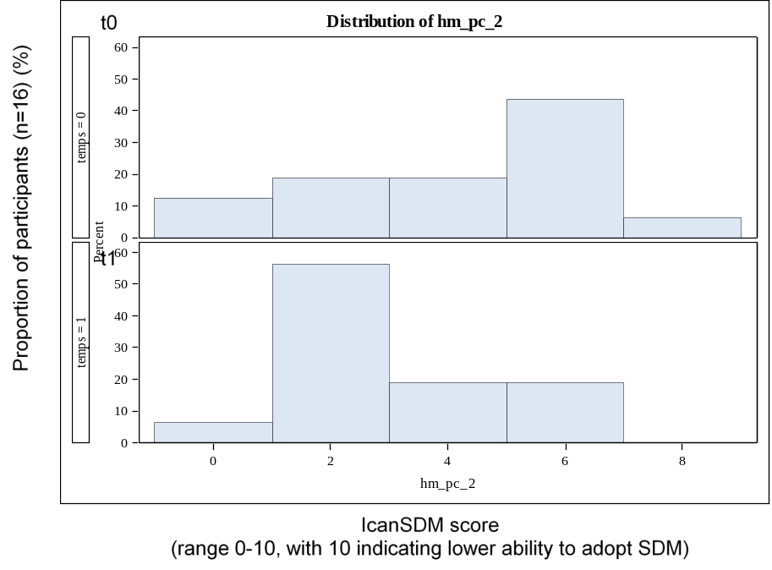

Figure B.3 Item 3
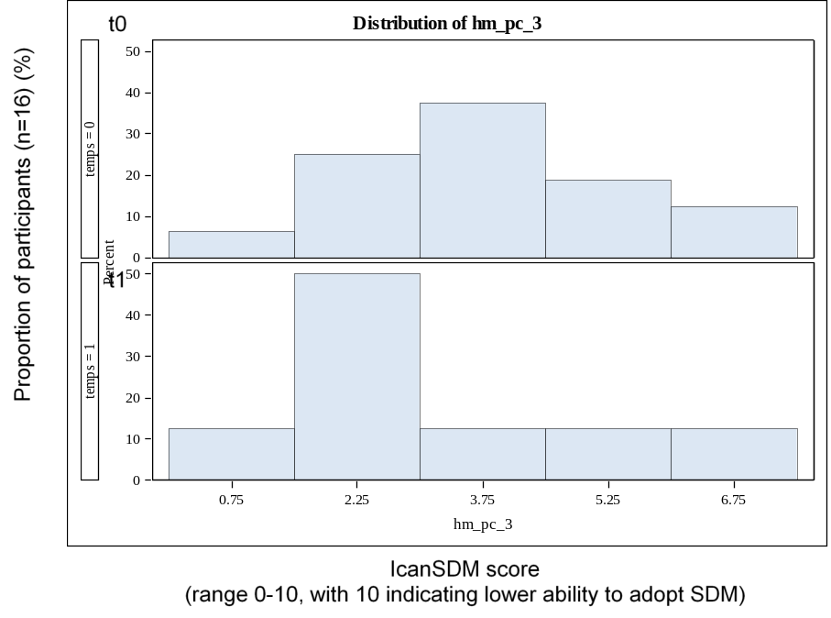

Figure B.4 Item 4
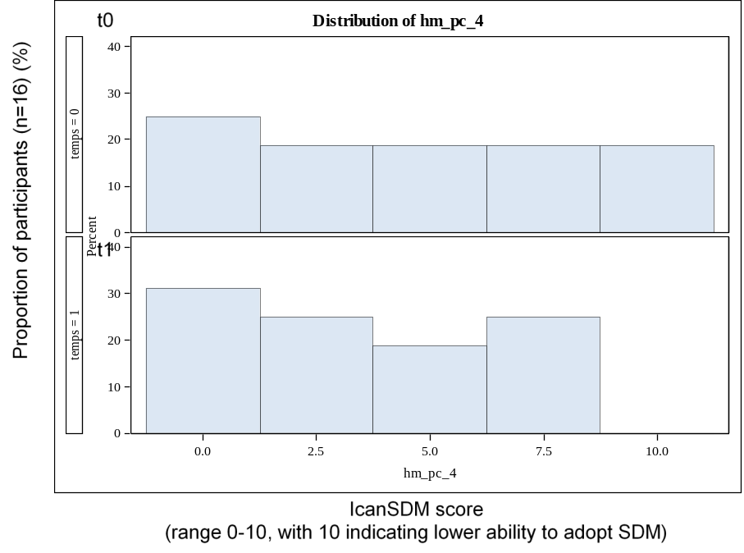

Figure B.5 Item 5
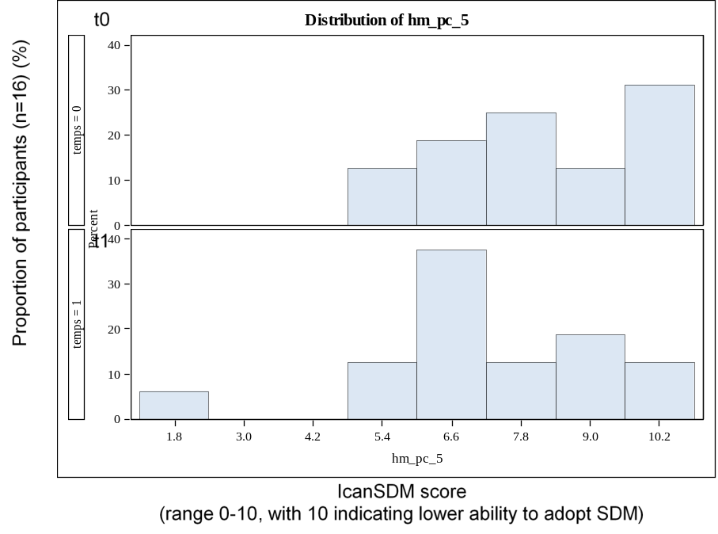

Figure B.6 Item 6
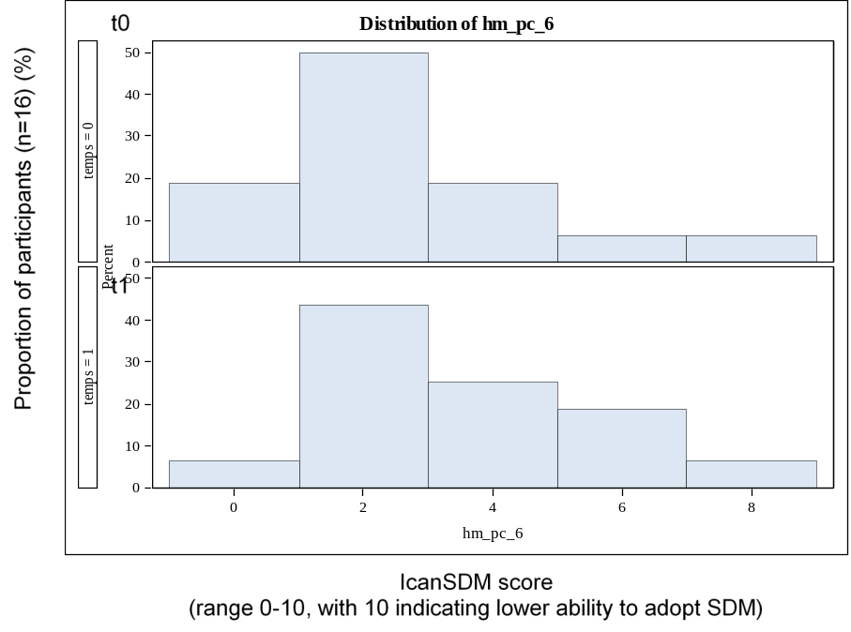

Figure B.7 Item 7
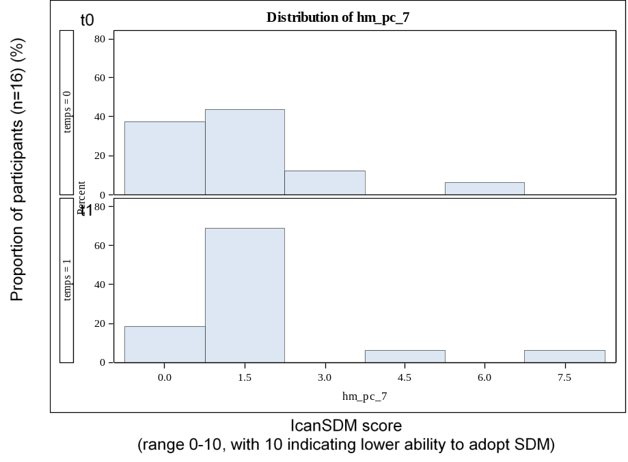

Figure B.8 Item 8
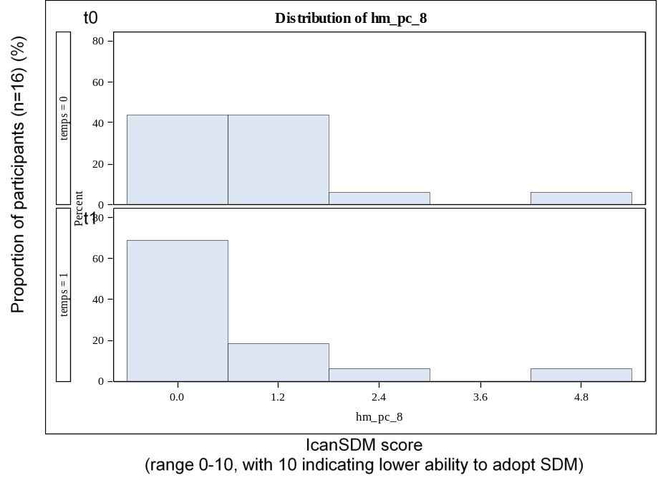

Figure B.9 Item 9
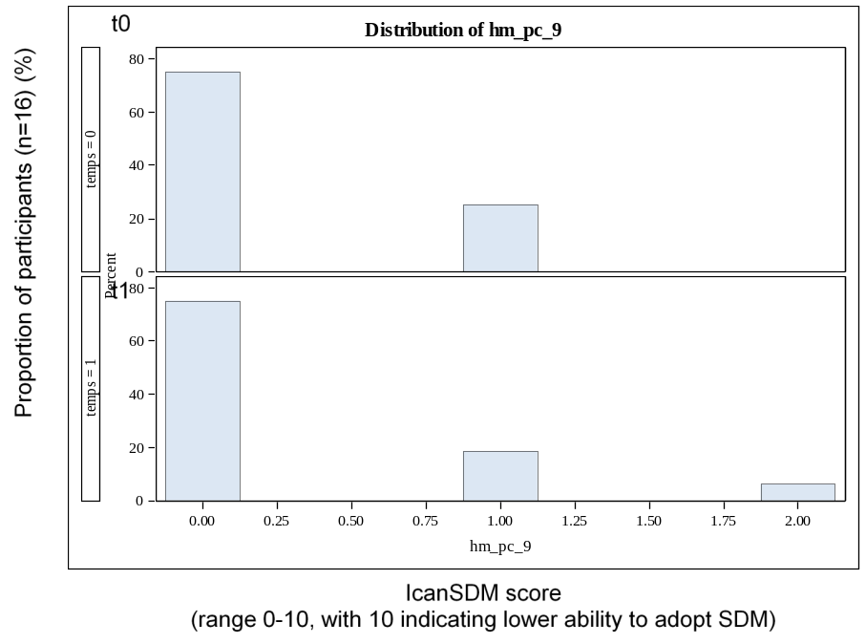

Figure B.10 Item 10
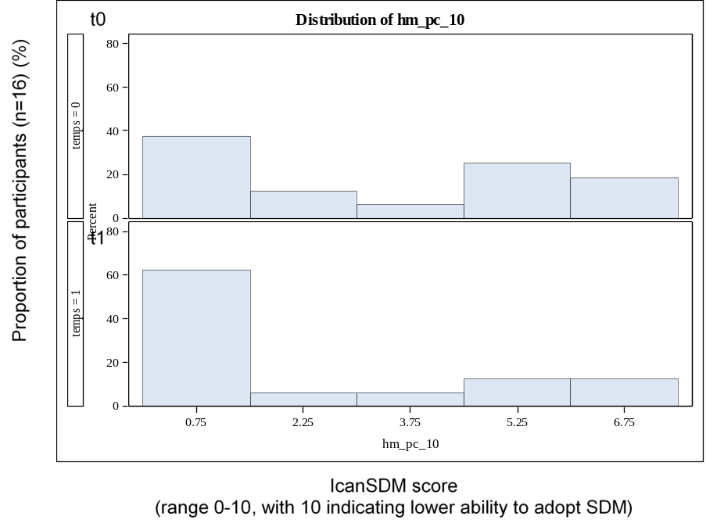

Figure B.11 Item 11
